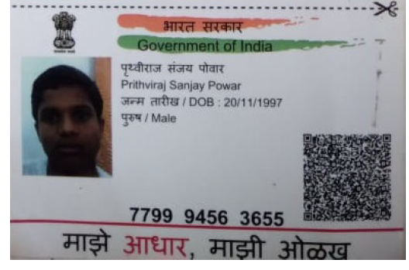

Vedio link:

https://methodhubindia-my.sharepoint.com/:v:/g/personal/jenifer_babu_method-hub_com/EWjmOxTgspRIkCtwiihqz9YB2WWssOVg5PG3ubXxPOn4LA

Prithviraj Powar
Pune, India | LinkedIn | 91+ 9370518487 | Prithvirajpowar21@gmail.com

WORK EXPERIENCE

Johnson Control India Pune, India
IT Analyst Feb 2022 – Aug 2023
- Strong knowledge of ETL tools and data integration techniques, ensuring seamless data flow between systems and formats, and facilitating effective data transformation for analysis.
- Proficiency in SQL, including data modeling and optimization, to efficiently store and retrieve data, and designing databases tailored to specific application requirements.
- Experience with big data frameworks like Apache Spark and Hadoop, enabling the efficient processing and analysis of large datasets in parallel, leveraging cloud platforms like AWS, Azure for scalability.
- Scripting and programming skills in languages like Python, coupled with version control using tools like Git, for developing custom data processing solutions and maintaining code for data-related tasks.

Emergen Teck Pune, India
Intern May 2021 - Oct 2021
- Assisting in the development of data pipelines, including data modeling and ETL processes, under the guidance of senior data engineering team members.
- Ensuring the efficient and accurate processing and analysis of data, contributing to the overall data engineering efforts.

Amazon Pune, India
C.S Associate Oct 2020 - April 2021
- Provide exceptional technical support for AWS cloud services via email, and chat, ensuring high customer satisfaction ratings.
- Diagnose and resolve technical issues related to AWS cloud services, collaborating with other technical teams as needed, and document customer interactions and technical solutions in a clear and concise manner.
- Achieved a 40% reduction in workload by implementing innovative ideas while managing the AWS server for the company, resulting in streamlined operations and quicker task completion.

SYNNEX Softech Pune, India
Test Engineer Jan 2019 - July 2020
- Proficient in managing the entire bug lifecycle, with extensive experience in banking, insurance, and financial services sectors.
- Skilled in using SQL and Python for testing, with exposure to tools like QTP and QC, ensuring comprehensive testing in both window-based and web-based software.
- Proven ability to provide robust quality assurance across diverse domains, leveraging expertise in bug lifecycle management and a range of testing tools and techniques.

Certificate
- Machine Learning Algorithm (Skill UP) (BY Self)
- RPA Developer Advanced Training Certifications 2019.4. (BY SELF)
- Oracle Database 12c: SQL Advance

Skills

Technical Skills: Python | Django | UI-Path | SQL | Git | AWS | Azure DevOps | Terraform| Jenkins | Docker | Kubernetes | Ansible

Honors & awards

Maharashtra State Shooting Championship 25th Capt. S. J. Ezekiel Memorial Novices-2022 Maharashtra, India
Secure first rank in Maharashtra State in 10M – Pistol Shooting competition

Pune University Pistol and Rifle Shooting Competition 2022 Pune, India
Secure 2nd Rank in Pune University 10M Pistol Men

Education
JSPM [Master in Computer Application (CGPA- 8.78/10) ] Pune, Maharashtra Date: May 2022
Relevant Courses: Database Management and Warehouse, Project management, Cloud Computing, Python programming. MIT Pune [ Bachelor in Computer Application (CGPA: 5.5/10) ] Pune, Maharashtra Date: OCT 2018 Relevant Courses: Software Engineering, Computer Networks, Programming in Java, Operating system.

